WeRateDogs Twitter Analysis Project

Analysis Report

The insights generated from the analysis includes:

The first analysis carried out was to identify how the rating numerator has changed over time.

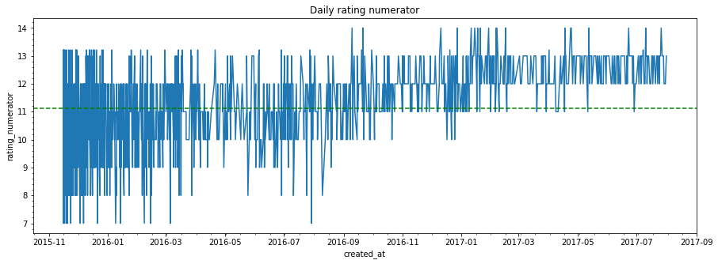

Figure 1. Change in numerator rating

The analysis above shows the average rating numerator is 11 but was exceeded beginning from November 2016 and remained steadily exceed from ending of january 2017

The second analysis was to view the most liked tweets.

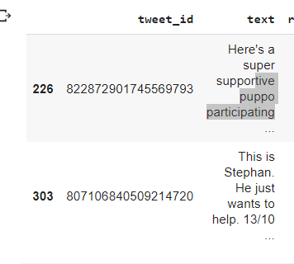

Figure 2. Top 2 Most liked Tweets

The top most liked tweets has favorite count of 120932 and 109249 respectively.

The next was to check the most liked dog type. The comparison was confirmed by check both the retweet counts and the favorite counts.

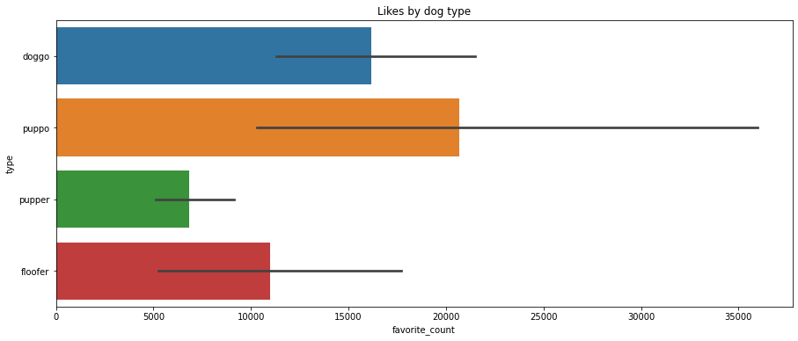

Figure 3. Most liked dog type

The analysis above indicates the most liked dog type are puppo and the least liked are the pupper.

The next step was to check the actual lengths of tweets and identify the most occurring length.

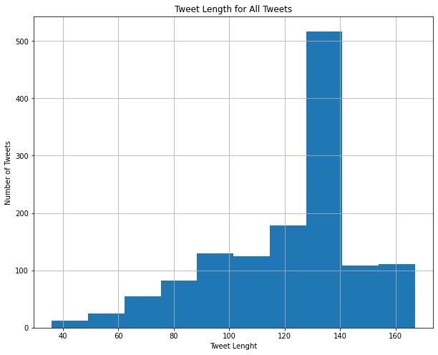

Figure 4. Most occurring tweet lengths

There are more tweets with lengths between 120 and 139.

The last two analyses carried out involved some feature extractions.

I wanted to compare likes and retweets by month and year, therefore, the appropriate month and year columns were extracted from the created_at columns.

The comparison below shows most retweets occur in June and the least occurs in November

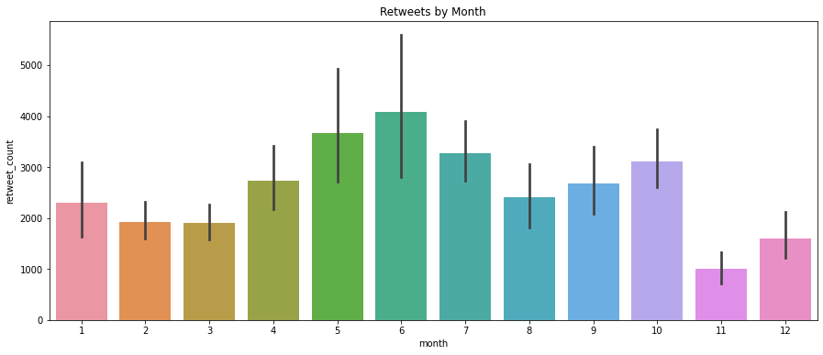

Figure 5. Retweets by month

Similarly, the yearly comparison below illustrates that there is a great difference in likes as the years progressed, with a lot of variance between 2015 and 2016.

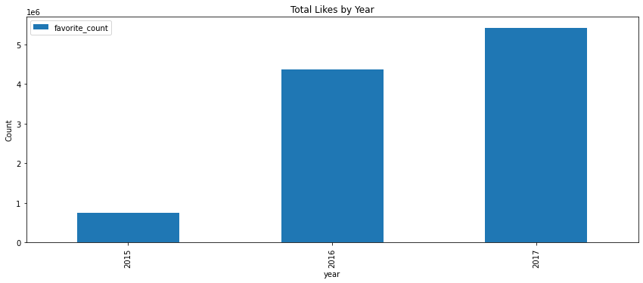

Figure 6. Likes by Year